# GROUP MEMBERS:

* **Muhammad Imad Ali (Student1168361)**
* **Aliyan Ahmed (Student1156830)**
* **Zia-Ur-Rehman Khan (Student1160630)**
* **Affifa Shaukat (Student1155692)**
* **Jaffar Abbas (Student1169699)**

# SUBMITTED TO:

* [**eprojects@aptechfze.ae**](mailto:eprojects@aptechfze.ae)

# PROJECT INSTRUCTOR:

* **Miss. Fariha Ahmed**

# CURRICULUM CODE:

* **6740**

# BATCH CODE:

* **1901G1**

**User Guide**



**ACKNOWLEDGEMENT**

***W****e are thankful to* ***Almighty, ALLAH*** *that by His grace we have been successful. We have tried our best to take all relevant and important topics in consideration so that this project may become comprehensive.*

*This is our* ***Fourth Year Semester E****-project. We have tried our best & struggled for a better outlook to come. This project has been developed in****.*** *We choose to make android application for* ***vehicle financing*** *as a project. We find easy to do coding*

*We earnestly hope that this project will provide all the necessarily information required for the user to fulfill their inspiration. However, suggestions for improvement of the project will be thankful received & acknowledgement****.***

***Thank You........***

**INTRODUCTION:**

We all need to visit customers for purchasing or sometimes it is an urgently situation that gifting whereas most of the other time it is a planned and visit markets. But in both the cases we have to visit the different apps to take cars or wait in long queues.

AJIZA Group is into vehicle purchasing services for long time and looking at the current shopping scene have decided to come up with an **APPLICATION,** which will host the BUYING services available in different cities.

Individuals will be able to search for specialist items in their surroundings and even book online.

Our application should also record the complete information regarding the Customers.

# PROJECT SNAPS

**NOTE: FIRST IMPORT THE DATABASE BACKPACK FILE BEFORE RUNNING THE PROJECT. THEN CHANGE THE CREDENTIALS FROM CONNECTION STRINGS ACCORDING TO YOUR NEED.**

# HOME SCREEN:

# LOGIN WITH AUTH

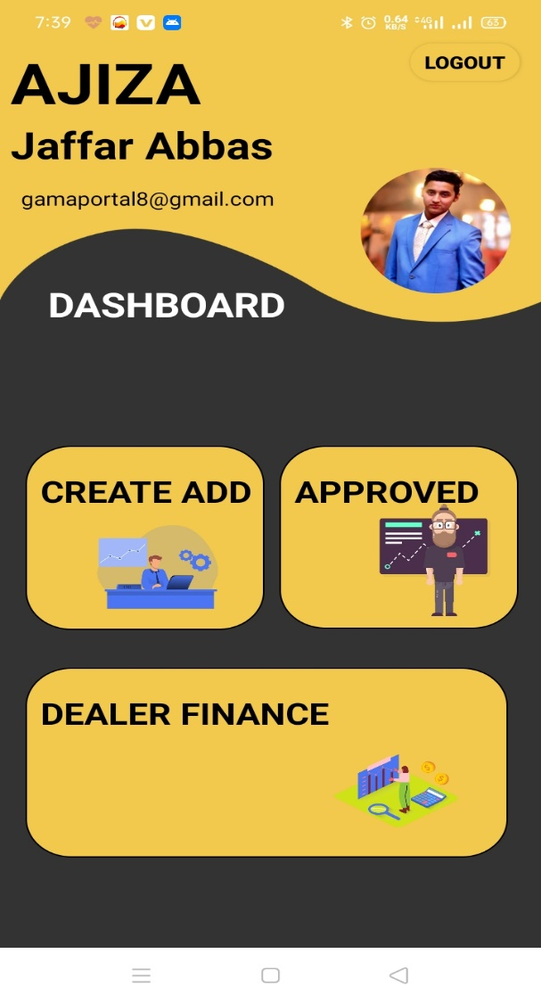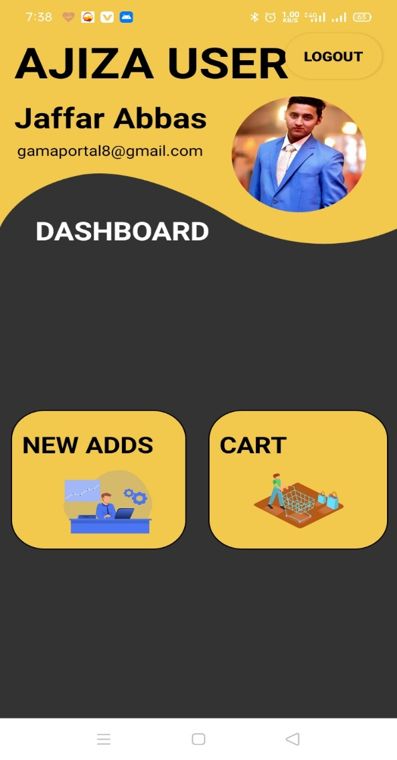

# LOGIN:

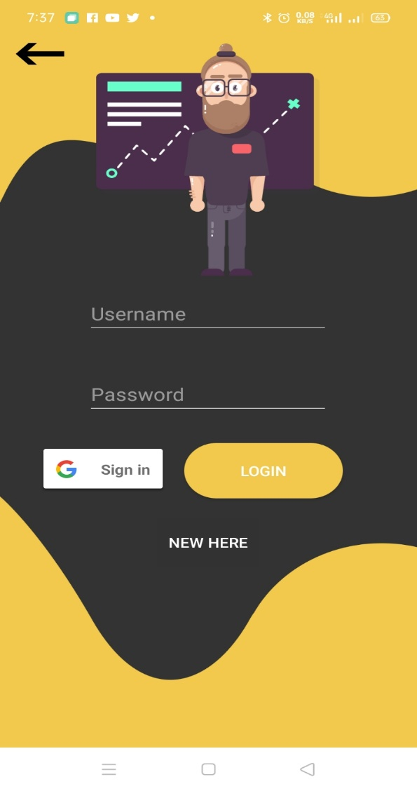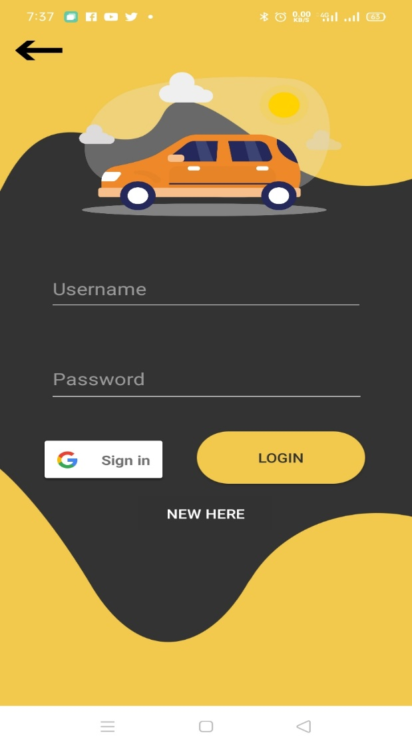

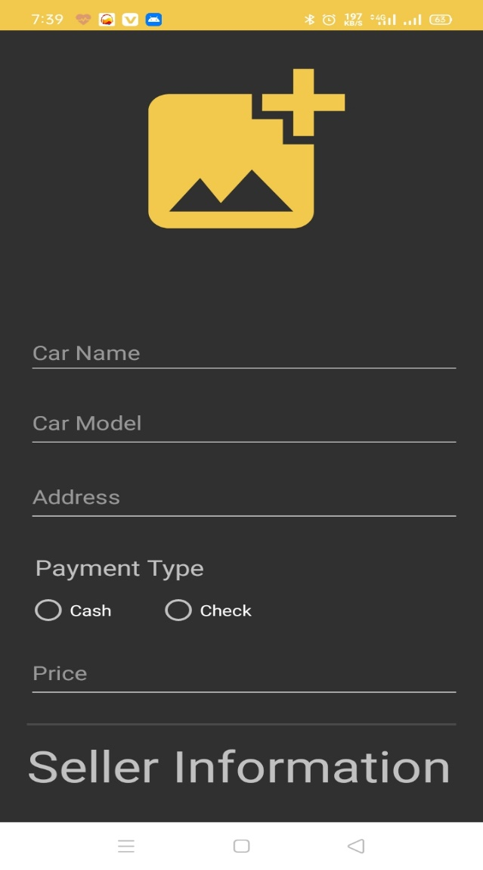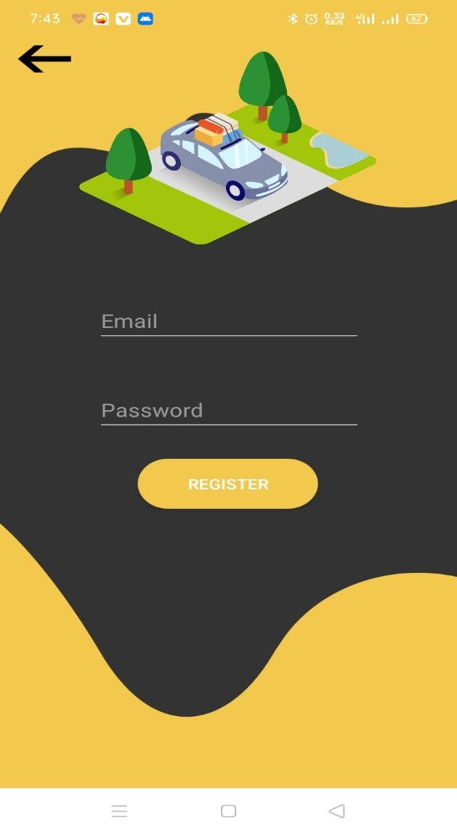

# CART & OTHERS

